WRITEUP FOR SQLI LABS:
LESS 1:
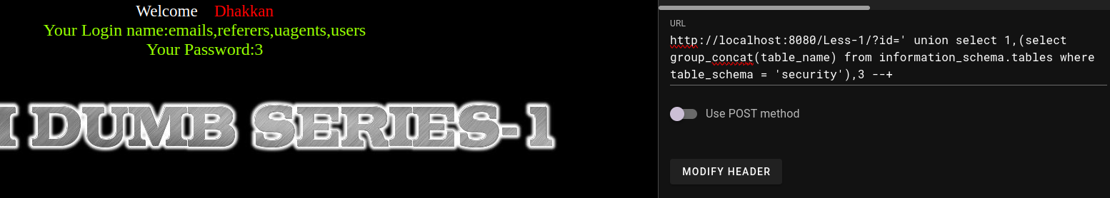
you have to give different payloads and find the table names and column name ....then u can provide them in the next query so that u can get all details in a single command.
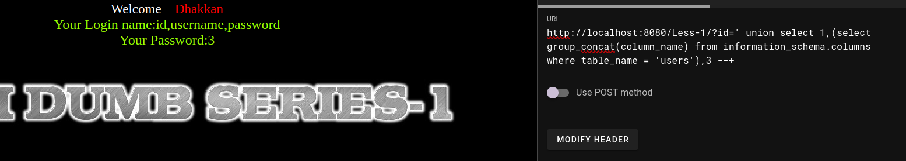
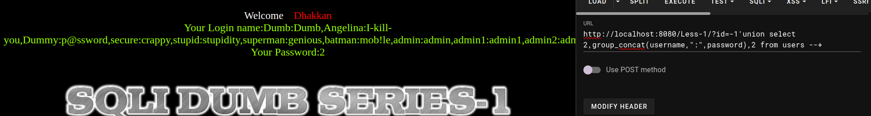

We use id coz there is id in that database
id = 0 wont have any value.....you can use any number which isnt there in the table
union select ====> for adding up our query with the already existing one
LESS 2:
gave the same query but this time without a single quote.
?id=0 union select 1,2,group_concat(0x3a,username,0x3a,password) from users --+

LESS 3:
?id=0’) union select 1,2,group_concat(0x3a,username,0x3a,password) from users --+
(use the same but....use a bracket too).
LESS 4:
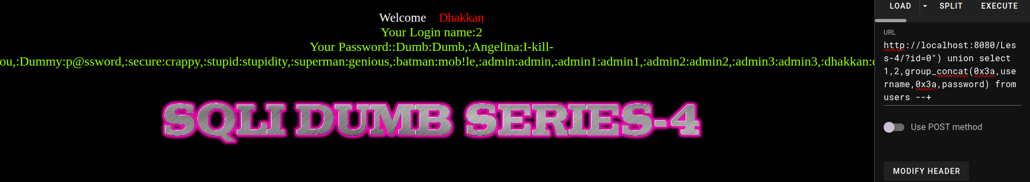
use same querry with “)

LESS 5:
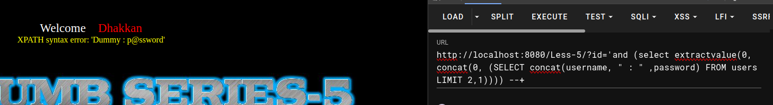
use subquery.use extractvalue.we give 0 as the column name.0 is an integer and it generates error.
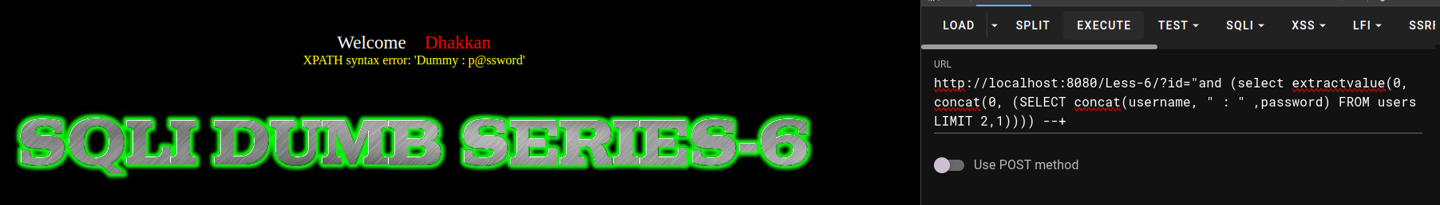
LESS 6: use double quotes instead of single quote (as level 5)
LESS 7:
LESS 8:
